 | Blue Door Nursery Spring newsletter. April 2019
It’s been a really busy term at Blue Door since Christmas, we have had lots of new children and families join us and we have really enjoyed getting to know them. The children have now all settled beautifully and are taking full advantage of all the lovely things we do at nursery. If you feel you’re missing out on what your child is up to, make sure you look at your Tapestry account to see if there are any photos or comments to look at. It helps us if you can ‘like’ a post so that we know you have seen it! |  | Since Christmas, we have welcomed Terri and Hayley to the nursery team and Lucy to the kitchen. We have also welcomed Katie, Tanisha and Chloe to our bank staff team (who cover when staff are on holiday or off work unwell). Lucy, our new cook, has been working hard getting to know the children and their different preferences – she will be suggesting a new menu after Easter. We will be asking you all to reconfirm your child’s allergies too as we know that some of these have now been diagnosed or have been discounted. |  |  | 15 years  In February Blue Door celebrated 15 years of providing care and education for children.  To celebrate we are having a Birthday Bash on Friday 26th April (6pm-7.30pm). We are planning a charity cake sale, activities and story time for the children and generally catch up chatter for the grown ups.  Bring yourself and your child/children (no unaccompanied children)  Bring some money for the charity cake sale  Bring some memories!  Please let us know via our Facebook page if you are coming – you are welcome to bring friends who are thinking about Blue Door, people you know who used to come to Blue Door or family members who are simply curious!  Find us on Facebook: The Blue Door Nursery, Seaford
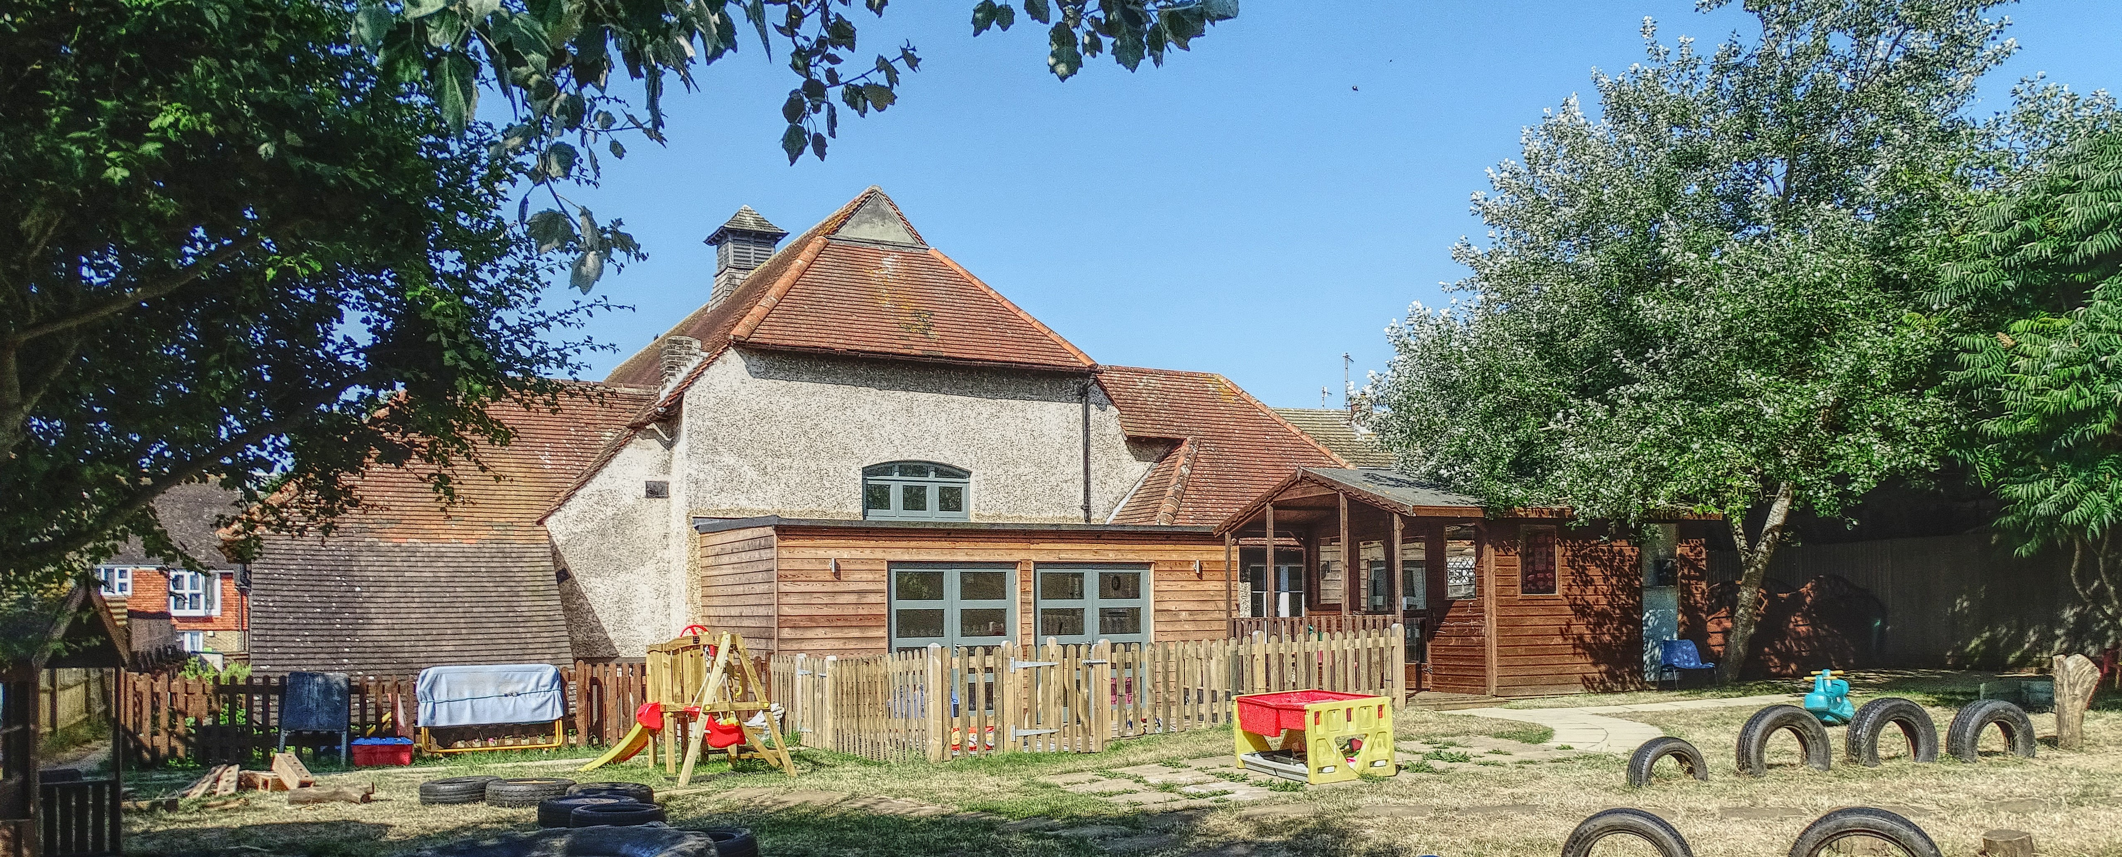

Reminders… at Blue Door we pride ourselves on our relationships with parents and we work really hard to make your nursery experience as smoothly as we can … there are a few things that you can do to help …
- If your child’s routine changes please let us know in writing (by email, via Tapestry or a good old fashioned note). This helps us ensure that messages are passed promptly to staff with the correct details  - If your child is going to be away from nursery please let us know – if you’re going on holiday it helps us with the staffing. If your child is unwell it helps us protect the health of other children and staff if we know what the issue is  - Please do not let children bring toys in from home, it makes it very tricky for the other children. They are also often lost or broken.  - Please label all your child’s clothes! |  |  | - Please make sure your child is dressed appropriately for the weather and for our garden. We like to run, climb, dig and jump in all weathers – there is no such thing as bad weather, only bad clothing!  - Please make sure you tell us if someone different to usual is collecting your child. We will not release a child to an adult we are not expecting – even if we know the adult. A quick mention at ‘drop off’ so a note can be put in the register is all it takes  - Please check your child’s bag, peg, pot before they go home – we are collecting a large number of things that should be at home! |  |  | - (Hopefully) we will see the sunshine soon. Please send your child with a sun hat. We put sun cream on mid-morning to ‘top up’ the application of cream you have made prior to coming to nursery. We do the same in the afternoon. Please do not send your child to nursery without protecting them with cream first.  - We are getting very booked up – if you need more sessions please let us know. If you know you want to book a sibling in then please make the booking now so that you are not disappointed! Also, tell your friends not to hang about!
DATES FOR YOUR DIARY…  Friday 26th April 6-7.30pm: Blue Door Birthday Bash  Tuesday 14th May Nursery photographs (groups)  Friday 24th May 1-6.30 INSET afternoon. Nursery will close at 1pm  Spring half term is 27th – 31st May  The Blue Door Nursery  01323 491821  enquiries@bluedoornursery.co.uk  www.bluedoornursery.co.uk |  |  |  | Thursday 4th July 6.30-8.30pm Parents’ evening and  Funding information.  Friday 19th July is the last funded day for term time only children

